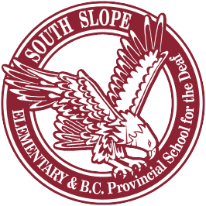

April 1, 2021

Dear Families,

I am following up with you on the letter sent to you by Board Chair Jen Mezei and Superintendent Gina Niccoli-Moen on Tuesday regarding changes to mask requirements in schools.

The Ministry of Education has advised school districts that all K-12 staff and all students in Grades 4-12 are required to wear a mask while indoors at school, including when they are at their desks or workstations. Kindergarten to Grade 3 students are strongly encouraged to do so, as well. Should you wish to view the updated guidance from the BC Centre for Disease Control you can find it here.

These changes do not replace what we must each continue to do: maximize physical distance (even when outside), wash hands frequently, do the Daily Health Check (found here), and stay home when sick.

School staff will continue to support student mask wearing through positive and inclusive approaches. Where students are not used to wearing masks indoors – especially in younger elementary grades – teachers will help students adjust, including sharing how to wear, take off and store masks (a video and poster can be found here). Kindly remember to send your child to school with a mask and a spare, if possible. We will also have masks on hand for those who forget to bring one.

As COVID-19 case numbers continue to rise, we are grateful for your ongoing vigilance. Thank you in advance for everything you are doing and continue to do to support each other and our community.

With appreciation,
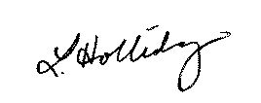
Lindsay Holliday
Principal, South Slope Elementary

